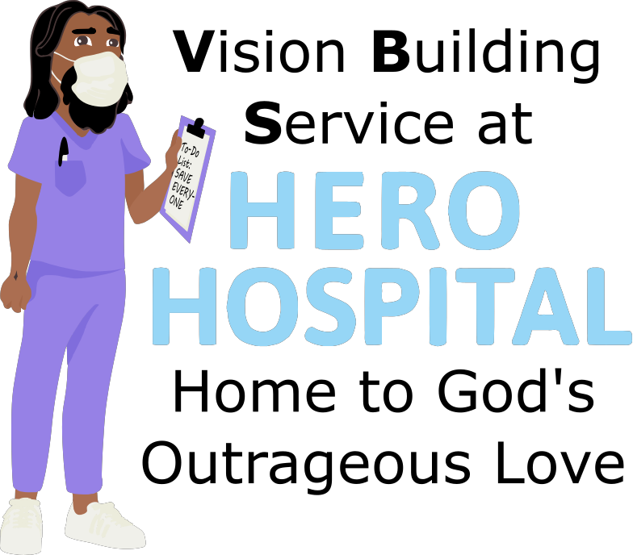
This week at Hero Hospital, we'll be learning that God's Kingdom is a
place for All!
Instructions for activities are found at: bannerblue.org/herohospital
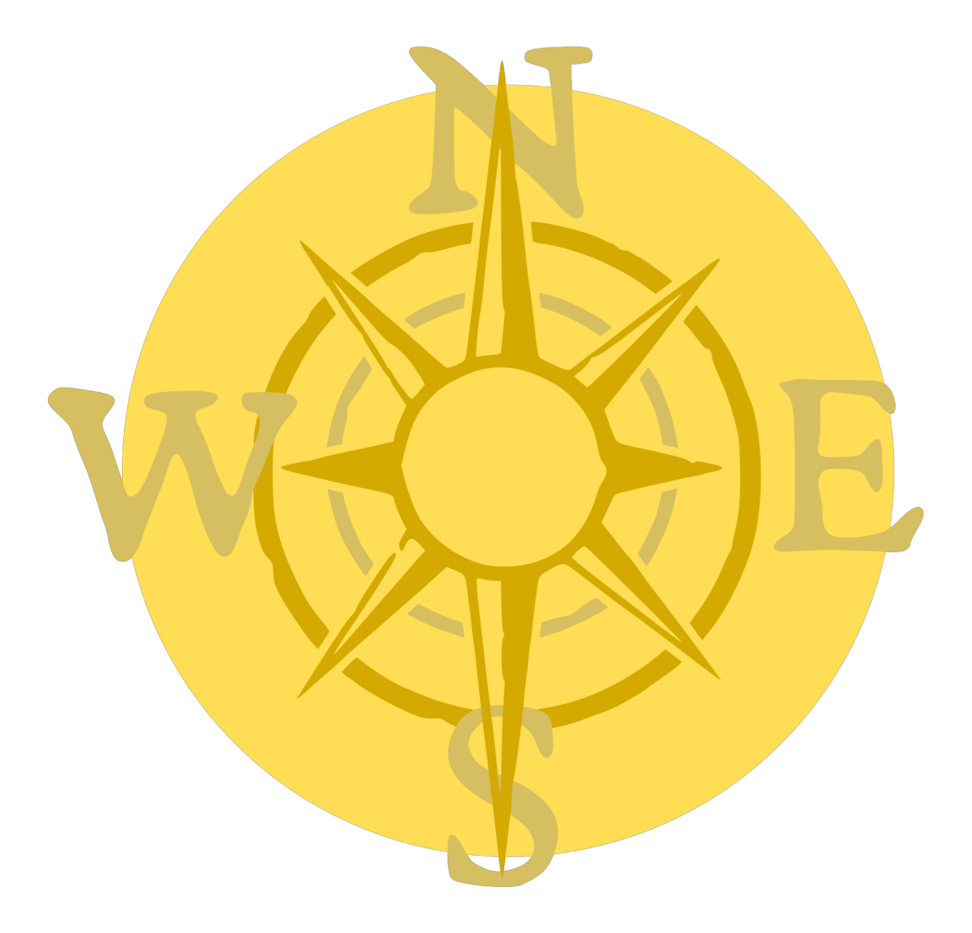
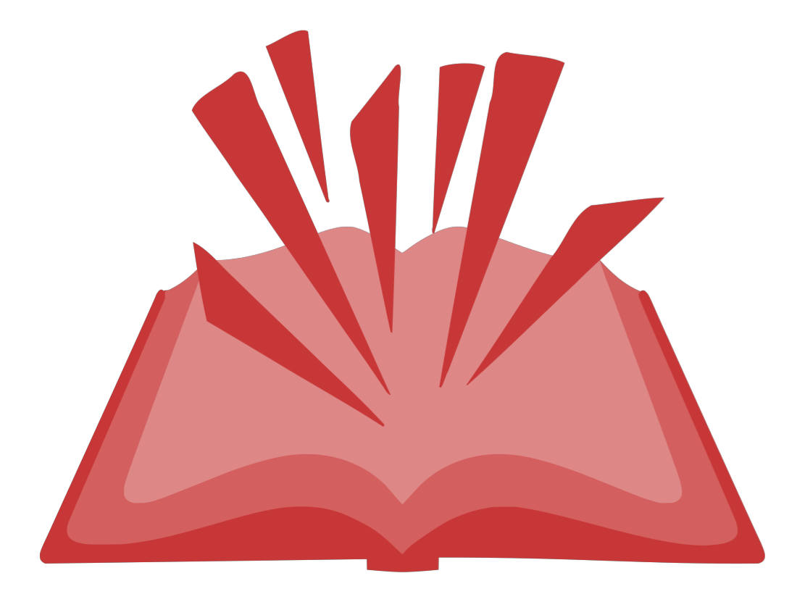
In Story, we'll learn from our historical guide Ella and hear how Jesus shared God's love with everyone!
Provided Supplies: Builder Book and Builder Bricks

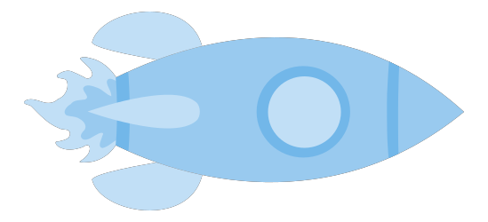
In Science, we'll experiment with building our own prosthetics out of supplies we can find at home.
Provided Supplies: Builder Book and Builder Bricks
Supplies from Home: Lego-style building bricks or common household items like tape, rubber bands, pipe cleaners, tongs, paper towel/toilet paper rolls, popsicle sticks, cardboard. One small ball like a bouncy ball or ping-pong ball.
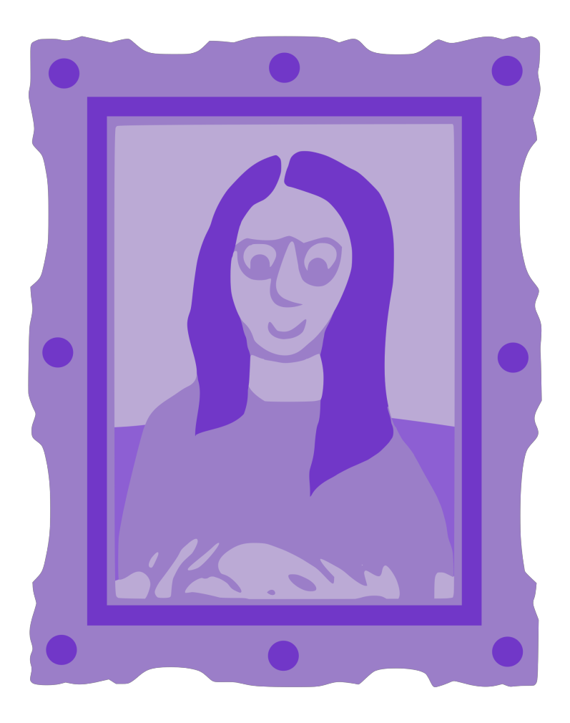
In Art, we’ll create a Pocket Prayer Quilt.
Provided Supplies: Builder Book and Builder Bricks, fabric, string.
Supplies from Home: glue.
Optional Supplies from Home: needle and scissors.
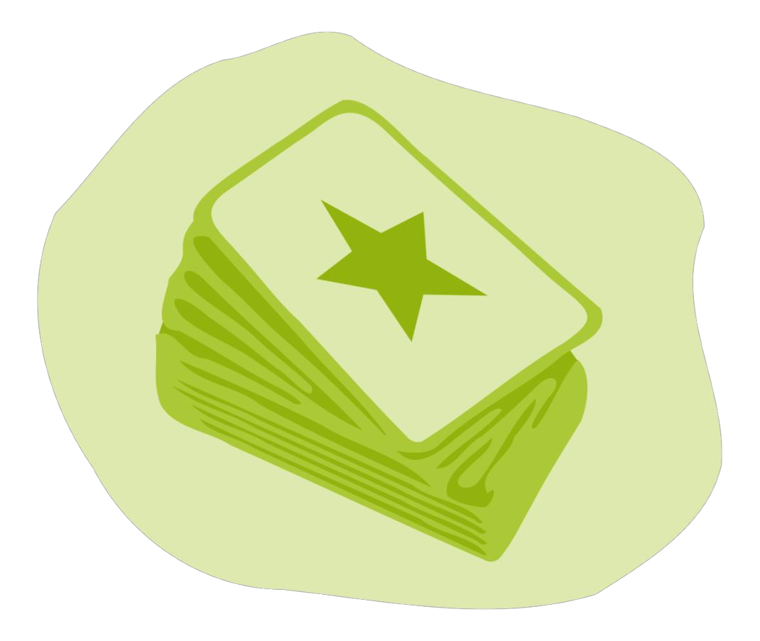
In Games, we’ll put a fun spin on Guess Who or Celebrities by using the Gospel Rules! Or you can find a creative version of tag on the website.
Provided Supplies: Builder Book and Builder Bricks.
Supplies from Home: Guess Who or Celebrities.

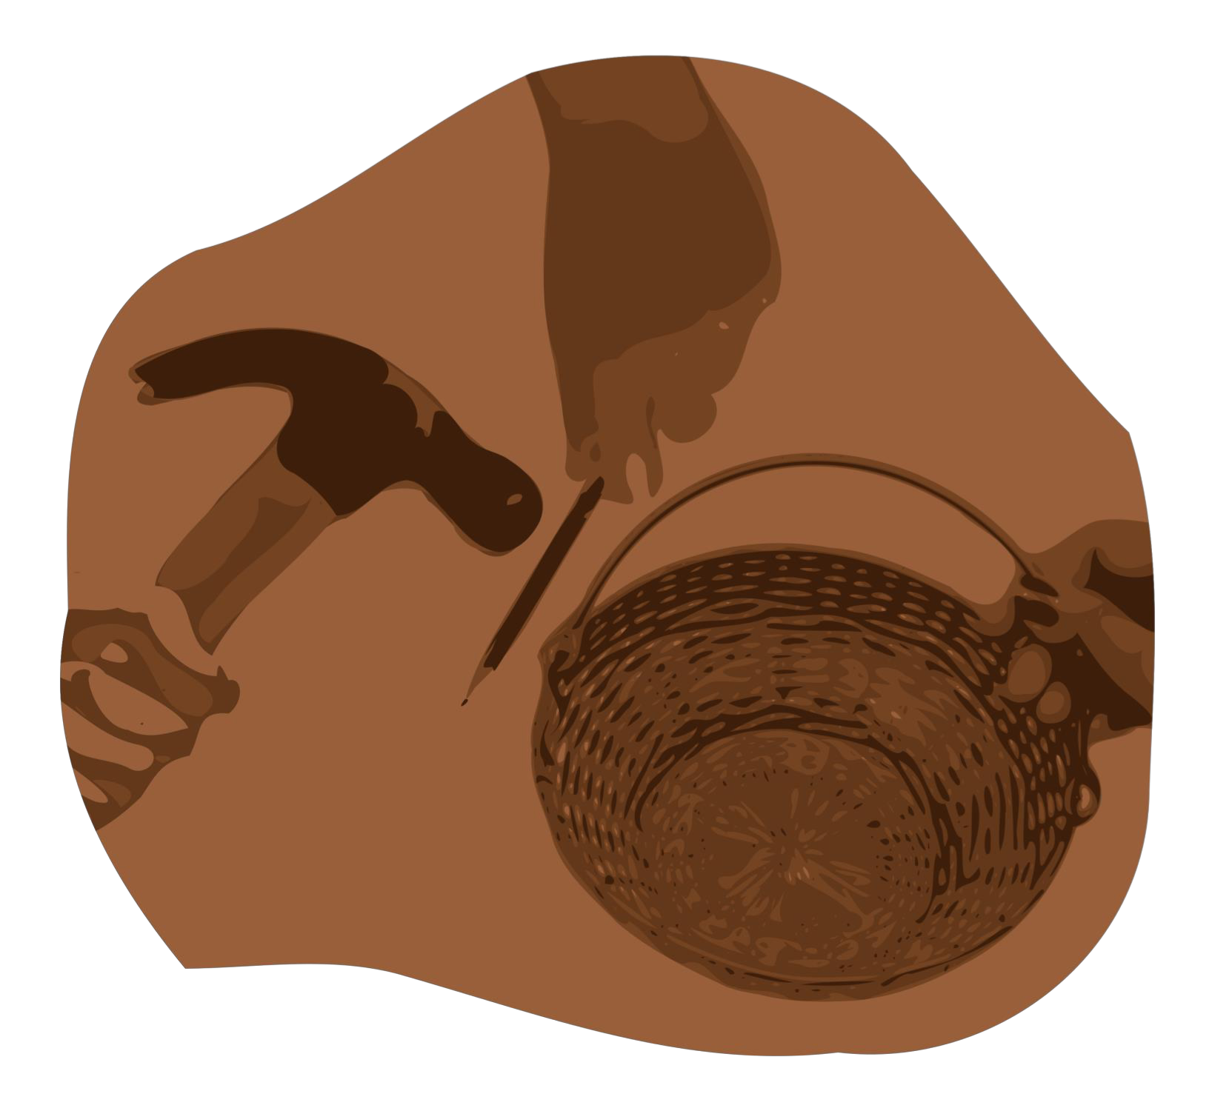
After learning about how Jesus wants us to make the world a better place by living out our faith, we’ll be inspired to do a Big Church Project! This week we’ll be inspired to use person-first language. Kids are invited to ask Pastor Katie about this when they return next week!
Provided Supplies: Builder Book and Builder Bricks.
During Worship we’ll sing and dance along with our VBS Music. Kids can also listen to the Music on the Hero Hospital website.
Provided Supplies: Builder Book and Builder Bricks.

After sharing all of these activities and learning about faith during worship and at home with their families, our kids will be able to answer this week’s Big Question: Does experiencing an illness or disability define all of who you are?
Provided Supplies: Builder Book and Builder Bricks.

