Worship Connection – The Luther Rose

After Martin Luther had become a well-known theologian, he was encouraged to create a personal seal that could be included on his writings. Luther created what we call The Luther Rose. He felt the seal expressed his theology or understanding of God and described the meaning of the seal in a letter to Lazarus Spengler. Luther wrote:

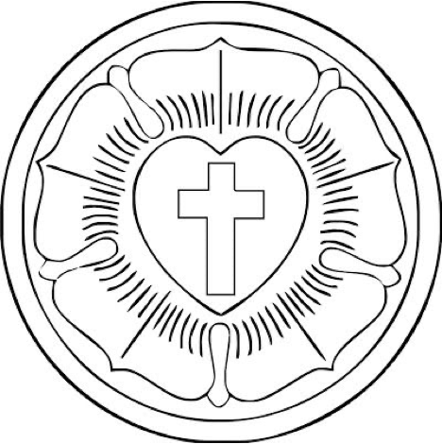
“I shall … tell you my original thoughts and reason about why my seal is a symbol of my theology. The first should be a black cross in a heart, which retains its natural color [red], so that I myself would be reminded that faith in the Crucified saves us. "For one who believes from the heart will be justified." Although it is indeed a black cross, which mortifies and which should also cause pain, it leaves the heart in its natural color. It does not corrupt nature, that is, it does not kill but keeps alive. "The just shall live by faith" but by faith in the crucified. Such a heart should stand in the middle of a white rose, to show that faith gives joy, comfort, and peace. In other words, it places the believer into a white, joyous rose, for this faith does not give peace and joy like the world gives. That is why the rose should be white and not red, for white is the color of the spirits and the angels. Such a rose should stand in a sky-blue field, symbolizing that such joy in spirit and faith is a beginning of the heavenly future joy, which begins already, but is grasped in hope, not yet revealed. And around this field is a golden ring, symbolizing that such blessedness in Heaven lasts forever and has no end. Such blessedness is exquisite, beyond all joy and goods, just as gold is the most valuable, most precious and best metal.

You are invited to color in your Luther Rose with the colors Martin Luther chose!
Create your own Seal!
Martin Luther designed his seal so that it expressed his understanding of who God is. He used symbols and colors that made sense to him and inspired his faith. As Lutherans we are all influenced by the beliefs and teachings of Martin Luther but our personal relationship with God might be a little bit different from Martin Luther’s personal relationship with God. On this side of your sheet you are encouraged to create your own Seal as an expression of your faith!

You can start from scratch using whatever symbols express your faith best. Examples: dove, tree, cross, lily, butterfly, burning bush, bread and grape, water, etc.

Or you can you can start with the Luther Rose and use different colors that express and inspire your faith.

